**OCN NI Essential Skills**

**Application of Number**

**Sample Paper**

|  |  |
| --- | --- |
| OCN NI Use Only | |
| Q | Mark |
| 1a |  |
| 1b(i) |  |
| 1b(ii) |  |
| 1b(iii) |  |
| 1c |  |
| 1d |  |
| 1e |  |
| 1f |  |
| 1g |  |
| 2a |  |
| 2b |  |
| 2c |  |
| 2d |  |
| 2e |  |
| 2f |  |
| 2g |  |

**Level 2**

**Learner name_________________________**

**Learner registration number______________**

**Learner signature _____________________**

**Centre ______________________________**

**Assessment Date ______________________**

Instructions to candidates:

You should have the following for this assessment:

* Pen with black or blue ink
* Pencil and eraser
* 30 cm ruler
* Calculator
* Protractor

You may use a calculator

General Instructions:

* There are 2 tasks to complete
* You must attempt both tasks
* Each task is worth 25 marks
* Read through each task carefully
* Show your working out; you may get marks for it
* Write all your working out and answers in this booklet
* Check your calculations
* Remember to put units on your answers
* Total marks available: 50
* You have 1½ hours to complete the assessment.

**Task 1 French Caravan Holiday**

Mr and Mrs Wallis are going on holiday to France.

They need to choose between a caravan site in the Loire and one in the Dordogne.

Mr and Mrs Wallis qualify for early booking discounts at both sites.

The tables below give caravan hire costs for each site:

**Sunshine caravan site, Loire** 

|  |  |  |  |  |  |  |
| --- | --- | --- | --- | --- | --- | --- |
| **Prices per night and early booking discounts *Prices in pounds*** | | | | | | |
| Caravan type | Beds | Sleeps | March-May | June | July & Aug | Sept onwards |
| Rossini | 1 | 2 sharing | £38 | £71 | £98 | £59 |
| Stay 7-11 nights and save | | | 30% | 15% | 10% | 30% |
| Stay 12 or more nights and save | | | 40% | 25% | 15% | 35% |

**French Country caravan site, Dordogne**

|  |  |  |  |  |  |  |
| --- | --- | --- | --- | --- | --- | --- |
| **Prices are per party per week *Prices are in Euros*** | | | | | | |
|  | **Easter** | **May** | **June** | **July** | **August** | **Sept onwards** |
| **1 bed caravan**  **sleeps 2 sharing** | €273 | €244 | €417 | €879 | €1030 | €303 |
| **Early booking offer! Book 2 weeks, get the 2nd week half price** | | | | | | |

***1 Euro = £0.80***

**1a** Compare the cost of staying at each site for 2 weeks in August with early booking discounts applied.

Which site will be cheaper and by how much? **(6 marks)**

Show your working and answers on the opposite page.

**1a**

Cheapest site: ____________________

Cost difference: £________________

A travel website displays 20 ratings for the Loire site.

They are listed below.

|  |  |  |  |  |  |  |  |  |  |  |  |  |  |  |  |  |  |  |  |  |
| --- | --- | --- | --- | --- | --- | --- | --- | --- | --- | --- | --- | --- | --- | --- | --- | --- | --- | --- | --- | --- |
| Site | Ratings  1=very poor 10=outstanding | | | | | | | | | | | | | | | | | | | |
| Loire Valley | 4 | 9 | 9 | 8 | 7 | 8 | 9 | 9 | 10 | 6 | 5 | 7 | 9 | 8 | 9 | 9 | 7 | 9 | 10 | 9 |

Rating reviews are also collected for the Dordogne site.

The range for the Dordogne ratings is 3 and the mean is 8.5.

**1b(i)** Calculate the range of the ratings for the Loire site.

**(1 mark)**

Show your working and answer below.

**1b(ii)** Calculate the mean of the ratings for the Loire site. **(2 marks)**

Show your working and answer below.

**1b(iii)** Using the range and the mean of the ratings for both sites, advise Mr. and Mrs. Wallis which would be the best site to choose. **(2 marks)**

Give your answer and say why you think this in the box below.

Mrs Wallis has a current balance of £385 in her bank account.

She needs to pay for the following holiday expenses immediately:

* 30% deposit on an overnight stop costing £125
* Total ferry cost of £359.20

**1c** Mrs Wallis thinks that she has enough money in the account to cover these expenses.

Is she correct? **(2 marks)**

Give your answer with clear justification in the box below.

Mr Wallis makes the following notes about the timing of their journey to the ferry in Dover:

* Leave house at 8am
* Home to Dover takes 5 hours 15 minutes
* Arrive at Dover at least 1 hour before ferry departs
* Ferry departs at 14:25
* Allow for 2 comfort breaks of 25 minutes each AND ¾ hour for lunch on the way to Dover

**1d** What is the latest time that they can leave home? **(3 marks)**

Show your working and answer in the box below.

Latest departure time: _______________

Mr and Mrs Wallis decide to look at weather records for 2012-2014 for

the Loire and the Dordogne to help them decide where to stay.

They prefer dry weather.

The average rainfall amount in millimetres for August 2012-2014 has been

recorded for each region in the table below:

|  |  |  |
| --- | --- | --- |
| **Site**  **Year** | **Loire** | **Dordogne** |
| **2012** | 15.0mm | 11.6mm |
| **2013** | 12.3mm | 8.1mm |
| **2014** | 15.9mm | 10.8mm |

**1e** Draw a comparative bar chart on the graph paper opposite that will show the rainfall data for the Loire and Dordogne.

Advise Mr and Mrs Wallis which site would be preferable and justify your answer. **(5 marks)**

Show your answer below and use the graph paper opposite for your bar chart.

**1e**

|  |  |  |  |  |  |  |  |  |  |  |  |  |  |
| --- | --- | --- | --- | --- | --- | --- | --- | --- | --- | --- | --- | --- | --- |
|  |  |  |  |  |  |  |  |  |  |  |  |  |  |
|  |  |  |  |  |  |  |  |  |  |  |  |  |  |
|  |  |  |  |  |  |  |  |  |  |  |  |  |  |
|  |  |  |  |  |  |  |  |  |  |  |  |  |  |
|  |  |  |  |  |  |  |  |  |  |  |  |  |  |
|  |  |  |  |  |  |  |  |  |  |  |  |  |  |
|  |  |  |  |  |  |  |  |  |  |  |  |  |  |
|  |  |  |  |  |  |  |  |  |  |  |  |  |  |
|  |  |  |  |  |  |  |  |  |  |  |  |  |  |
|  |  |  |  |  |  |  |  |  |  |  |  |  |  |
|  |  |  |  |  |  |  |  |  |  |  |  |  |  |
|  |  |  |  |  |  |  |  |  |  |  |  |  |  |
|  |  |  |  |  |  |  |  |  |  |  |  |  |  |
|  |  |  |  |  |  |  |  |  |  |  |  |  |  |
|  |  |  |  |  |  |  |  |  |  |  |  |  |  |
|  |  |  |  |  |  |  |  |  |  |  |  |  |  |
|  |  |  |  |  |  |  |  |  |  |  |  |  |  |
|  |  |  |  |  |  |  |  |  |  |  |  |  |  |

Mrs Wallis has heard that the average monthly temperature in the Loire in August last year was 70°F.

She knows of 2 methods for changing temperatures in degrees Fahrenheit to degrees Celsius.

**Method A**: As an estimate, subtract 30 from the given temperature and divide by 2.

**Method B**: For an accurate result use the formula:

$C= \frac{5(F-32)}{9}$

where C = temperature in °C and F = temperature in °F

**1f** Convert 70°F to °C using both methods and compare the results.

Comment on the accuracy of method A. **(4 marks)**

Show your working and answers below.

Comment: _________________________________________

_________________________________________________

**Blank page**

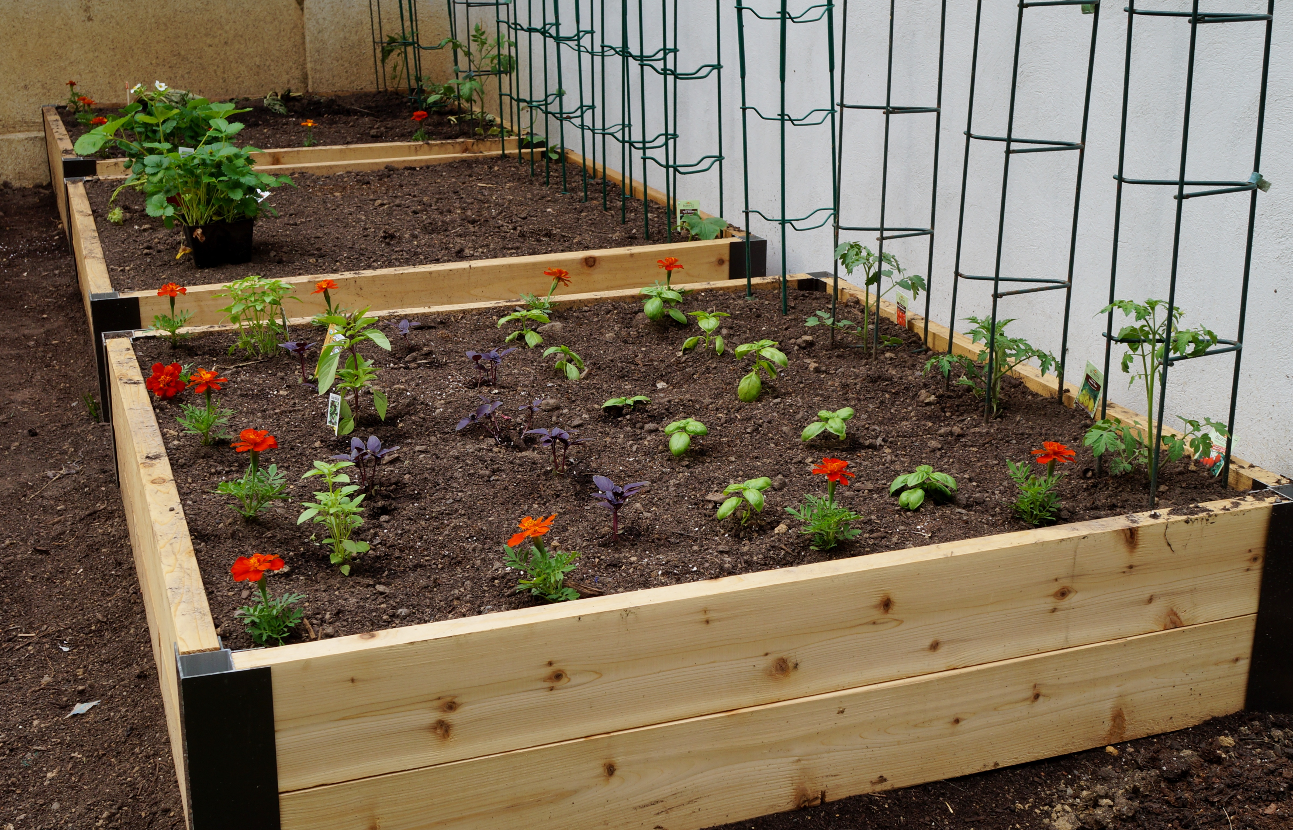

**Task 2 The Garden**

Emma has a rectangular plot of land measuring 8m by 6m.

She wants to fit 3 raised flower beds in this plot.

Each raised bed is 3m long and 1.5m wide.

There needs to be a pathway at least 1m wide around each raised bed.

**2a** Using the graph paper opposite, draw a scale plan of the plot with the 3 raised beds suitably positioned.

Use a scale of 1:50.

Show working clearly below with sketches if used. **(5 marks)**

|  |  |  |  |  |  |  |  |  |  |  |  |  |  |
| --- | --- | --- | --- | --- | --- | --- | --- | --- | --- | --- | --- | --- | --- |
|  |  |  |  |  |  |  |  |  |  |  |  |  |  |
|  |  |  |  |  |  |  |  |  |  |  |  |  |  |
|  |  |  |  |  |  |  |  |  |  |  |  |  |  |
|  |  |  |  |  |  |  |  |  |  |  |  |  |  |
|  |  |  |  |  |  |  |  |  |  |  |  |  |  |
|  |  |  |  |  |  |  |  |  |  |  |  |  |  |
|  |  |  |  |  |  |  |  |  |  |  |  |  |  |
|  |  |  |  |  |  |  |  |  |  |  |  |  |  |
|  |  |  |  |  |  |  |  |  |  |  |  |  |  |
|  |  |  |  |  |  |  |  |  |  |  |  |  |  |
|  |  |  |  |  |  |  |  |  |  |  |  |  |  |
|  |  |  |  |  |  |  |  |  |  |  |  |  |  |
|  |  |  |  |  |  |  |  |  |  |  |  |  |  |
|  |  |  |  |  |  |  |  |  |  |  |  |  |  |
|  |  |  |  |  |  |  |  |  |  |  |  |  |  |
|  |  |  |  |  |  |  |  |  |  |  |  |  |  |
|  |  |  |  |  |  |  |  |  |  |  |  |  |  |
|  |  |  |  |  |  |  |  |  |  |  |  |  |  |

Raised beds are 3m long, 1.5m wide and 85cm high.

Beds need to be filled with topsoil to within 10cm of the top of the container.

Topsoil is delivered in 1000 litre bags.

**2b** How many bags of topsoil will Emma need to fill all three raised beds?

Justify your answer using suitable calculations. **(5 marks)**

**1m3 = 1000 litres**

Show working clearly below.

Number of bags needed: _______

**2c** Show a check you have used in your calculation in 2b. **(1 mark)**

Emma wants to grow cabbages in one of the raised beds.

Raised beds are 3m long and 1.5m wide.

There will need to be at least 30cm between each plant and also between plant and border.

Packs of plants are sold in multiples of 6.

**2d** Calculate how many packs Emma will need to buy. **(4 marks)**

Show working below with sketches if necessary.

Number of packs: _________________

In another raised bed Emma wants to plant strawberries.

She needs 20 plants.

Bobbies Garden Centre sell packs of 4 plants at £1.80 per pack.

Sunny Garden Centre has an offer of 50p per plant or buy 4 get 1 free.

**2e** Which garden centre will give Emma the best deal?

**(3 marks)**

Give your answer with clear justification below.

**Blank page**

Emma creates a tally chart to record the sightings of various bird species in her garden on a day in June:

Paul sees a bird in Emma’s garden on the same day as the sightings are recorded.

**2f** Using the tally chart below calculate the probability that the bird will be a thrush? (3 marks)

Express the probability in **two** different ways.

Show your working on the opposite page.

|  |  |
| --- | --- |
| **Bird Type** | **Tally** |
| **Magpie** |  |
| **Blue tit** |  |
| **Chaffinch** |  |
| **Wood pigeon** |  |
| **Robin** |  |
| **Thrush** |  |

**2f**

Probability of bird being a thrush: _________ OR ___________

Emma finds the following recipe for bird feed on a website:

‘Make your own bird feed by mixing 3 parts of seed with 2 parts of nuts’.

Emma already has 2.7kg of seeds but no nuts.

The local pet shop sells nuts in 1kg bags at 68p per bag.

**2g** How many bags of nuts will Emma have to buy to mix with all the seeds she already has and what will it cost her? (4 marks)

Show working below.

Number of bags: ________

Cost: £___________